1. Create the “BCM_ORDER_MGT" table using the script - DB_Prerequisite.sql

Change prequite sql fields to make it compatible to MSSQL

Did not change any original values

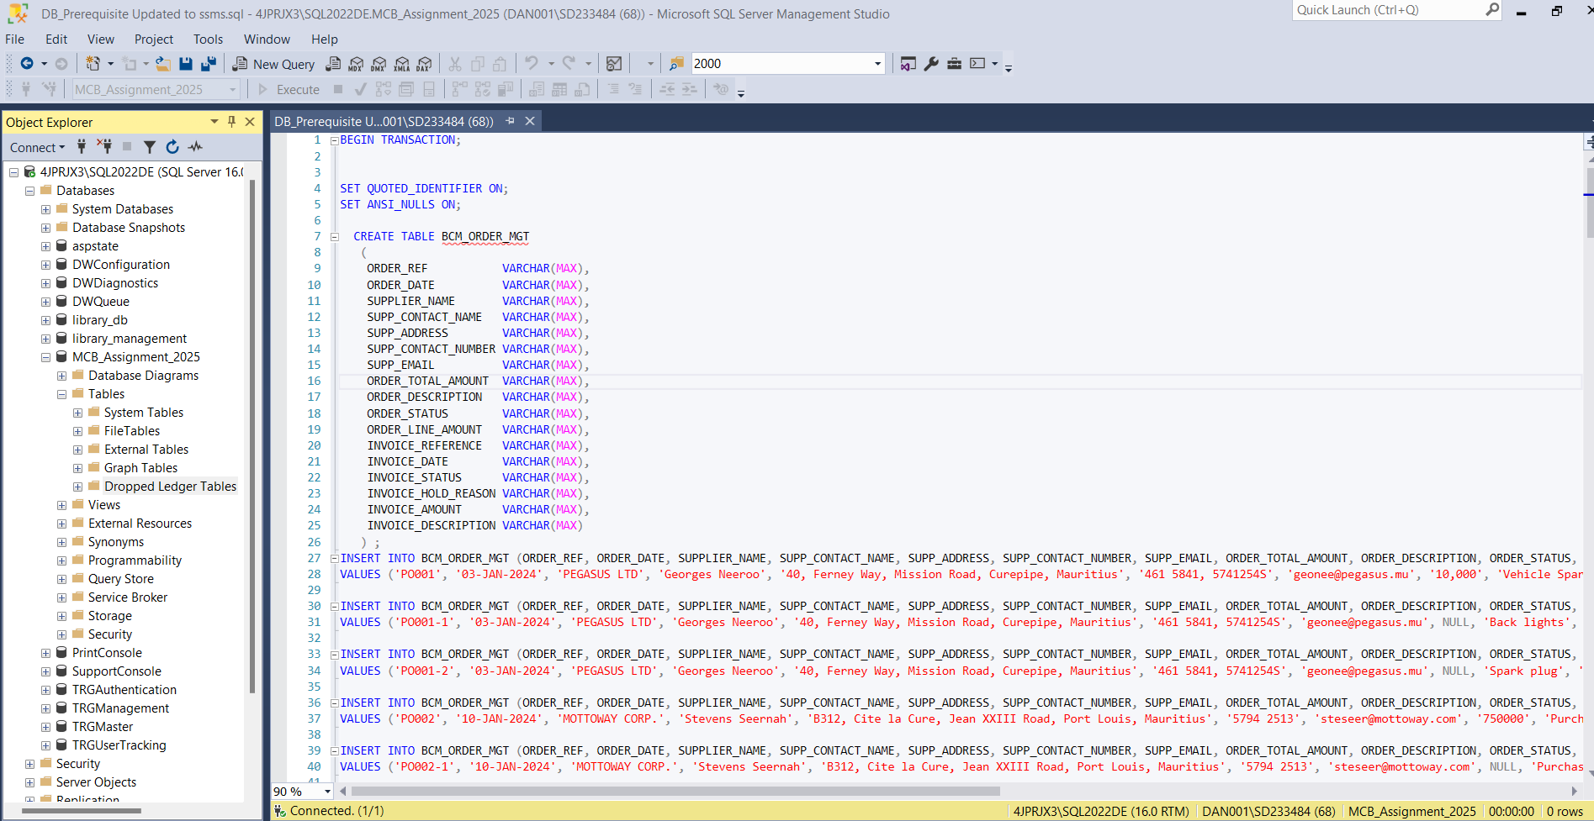

Run Script:

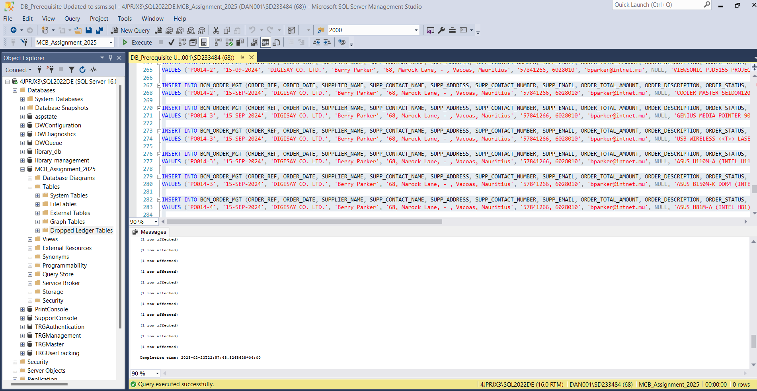

Viewing inserted values in the BCM_ORDER_MGT Table

Script: select * from BCM_ORDER_MGT

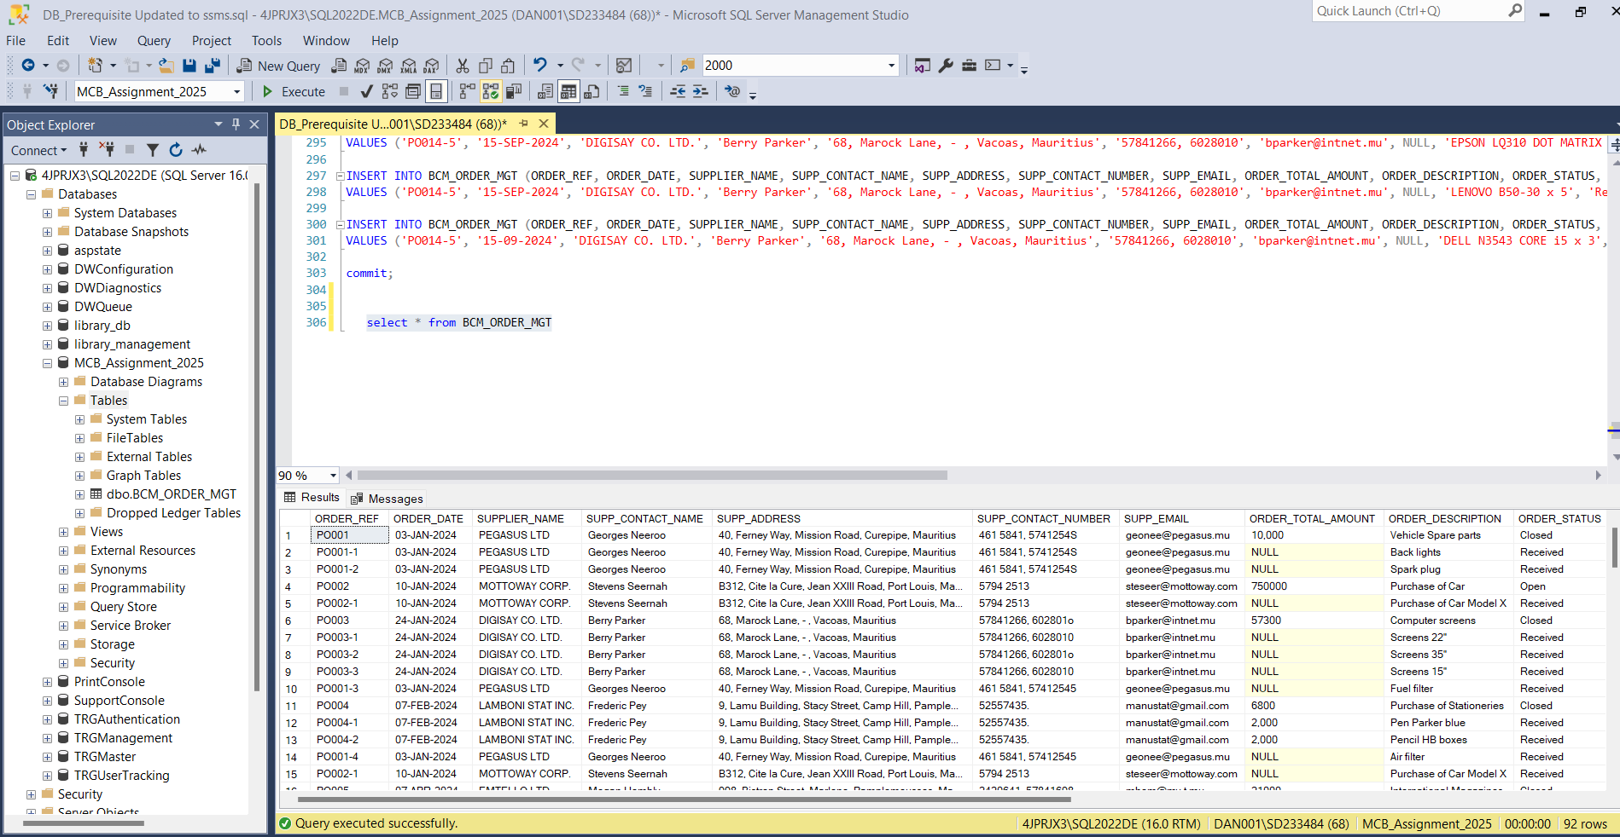

1. Based on the data provided implement a database schema with necessary tables, columns, data types and constraints. Create your tables in the database with appropriate naming convention. The tables should be appropriately normalized.

For the following questions, you are expected to create a database package with appropriate functions or procedures. All the database objects that you need to create shall be available on your working database environment and properly compiled.

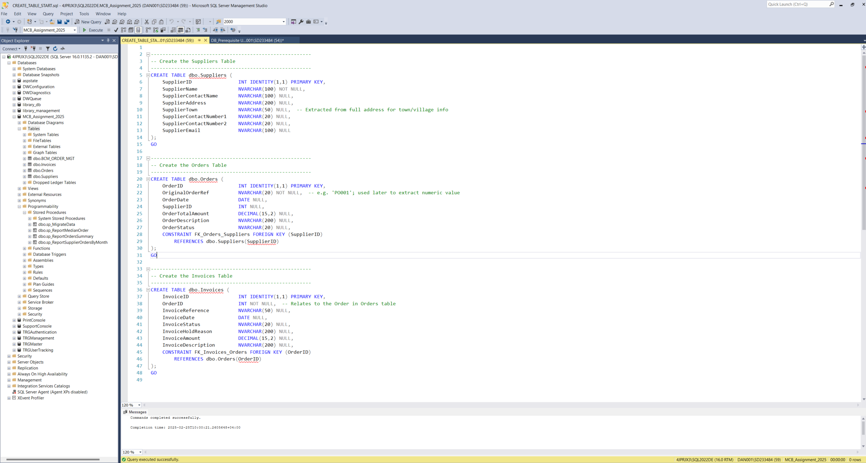

Execute script:

Upon Successfully executed scrip, 3 tables were create dbo.Invoices, dbo.Orders and dbo.Suppliers

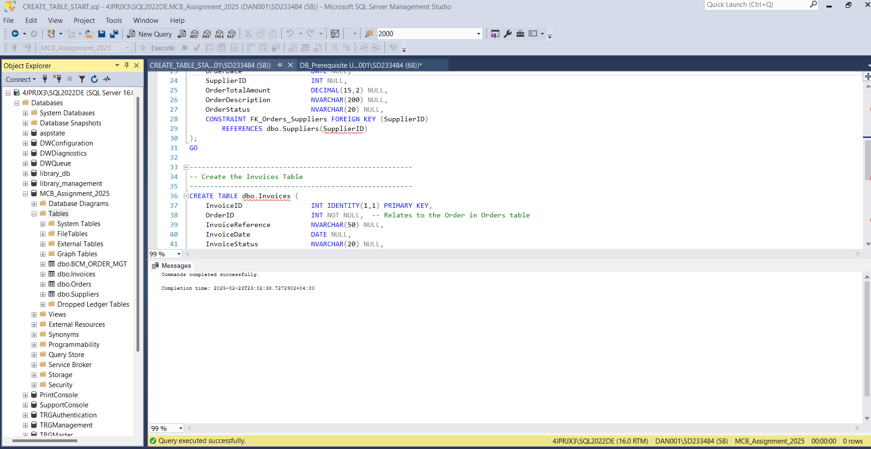

3 Tables created:

1. Develop a SQL procedure to trigger a migration process that will extract information from table "BCM_ORDER_MGT" and load them in tables that you created with proper data format.

• Store the Supplier address such that the Town\Village info can be readily retrieved

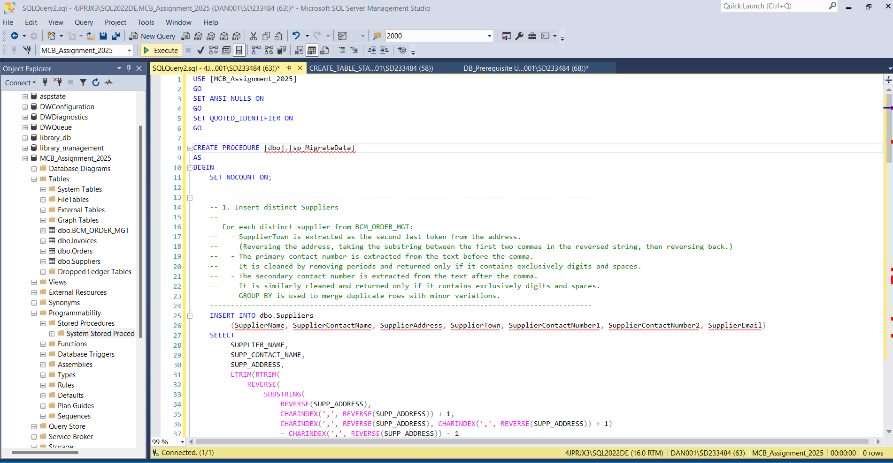

Executing Stored procedure script

Created a stored procedure to load them in tables in proper data format, sanitized and normalized the data before tabulating in tables

Execute stored procedure to trigger migration process

Migration of records in the tables below  
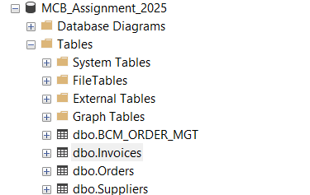

Dbo.Invoices data:

Dbo.Orders data:

Dbo.Suppliers data:

1. The owner wishes to have a report displaying a summary of Orders with their corresponding list of distinct invoices and their total amount grouped by the Supplier Region. The report shall contain the details as per table below ordered by descending Order Total Amount on top region-wise. Implement a Stored Procedure or Function to return the required information.

Created a function for supplier name to adhere expected outcome for upper case and lower case character

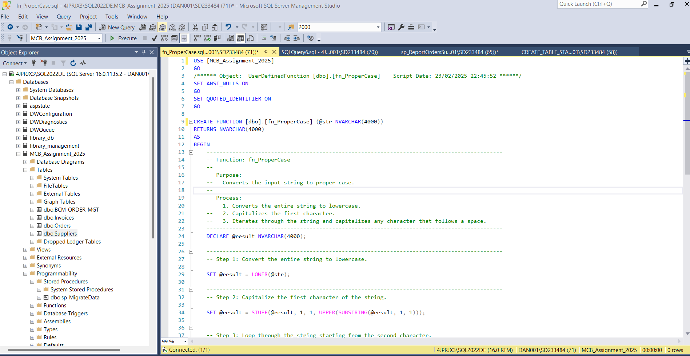

Executed Function created successfully

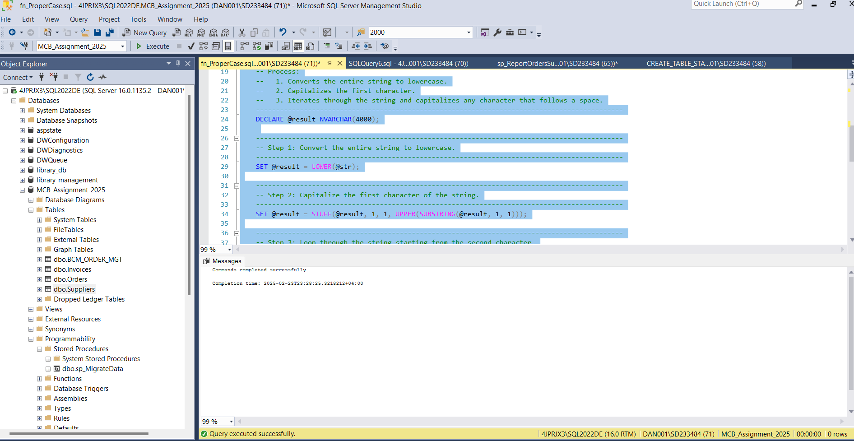

Created stored procedure ‘**sp_ReportOrdersSummary’** to get expected outcomes

Executed Stored Procedure Successfully:

Stored procedure was created successfully

Executed Stored Procedure script Successfully s with their corresponding list of distinct invoices and their total amount grouped by the Supplier Region

1. Return details for the median value of the Order Total Amount from the list. Only one record is expected with the following information. Implement a Stored Procedure or Function to return the required information.

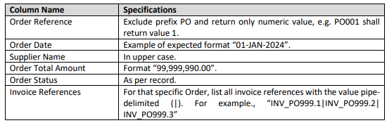

Created stored procedure median to return expected values

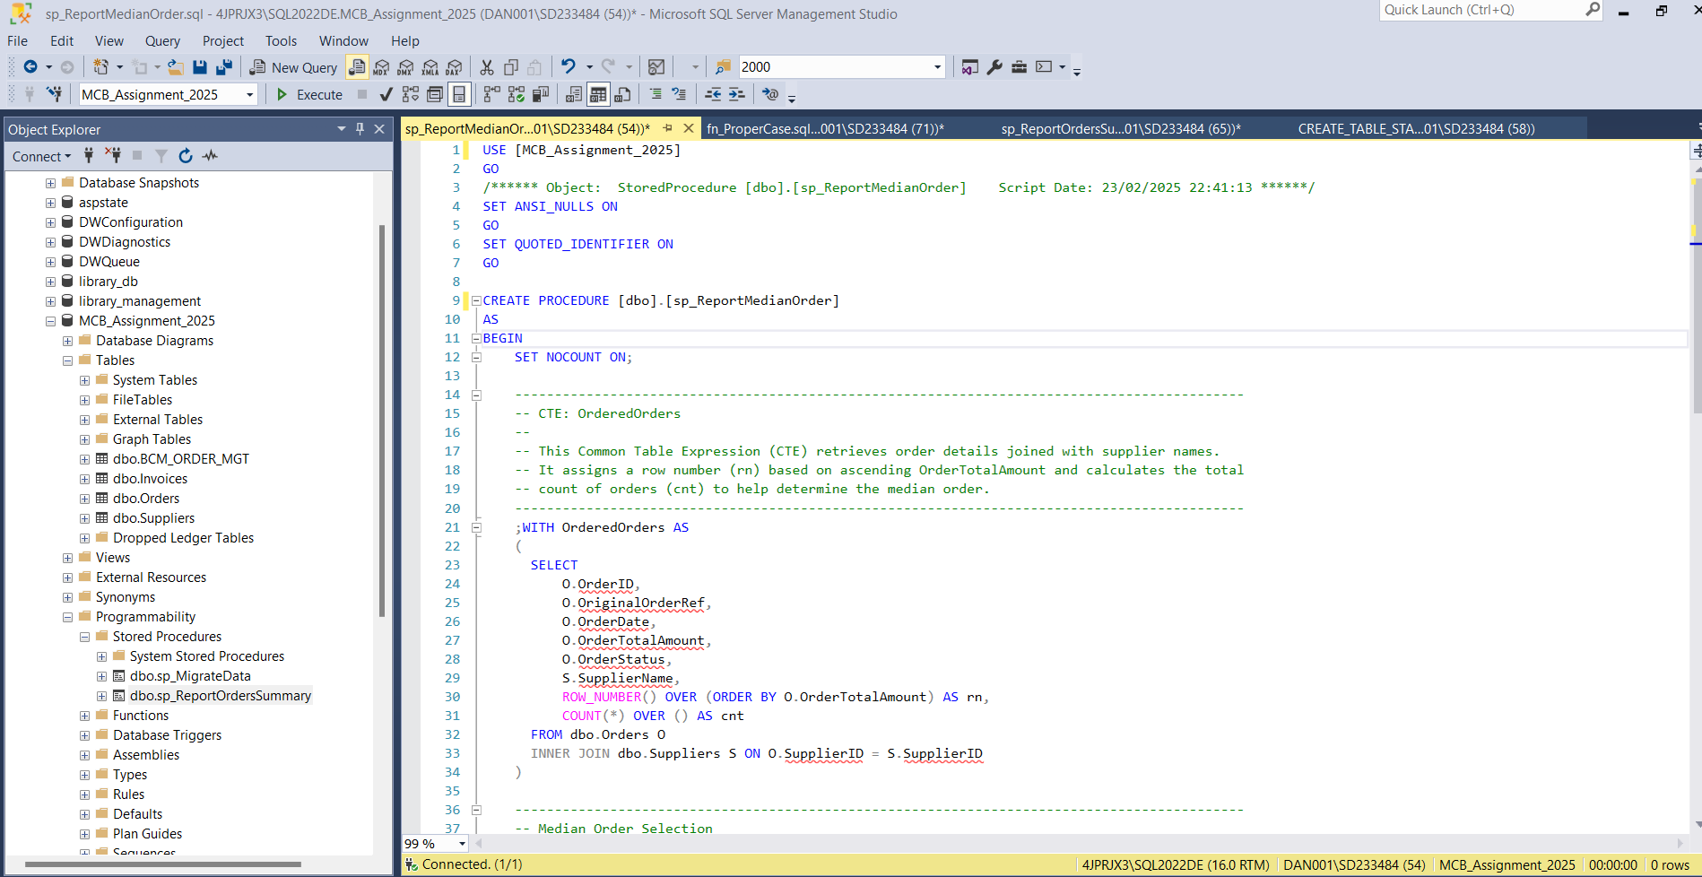

Run to Create stored procedure successfully

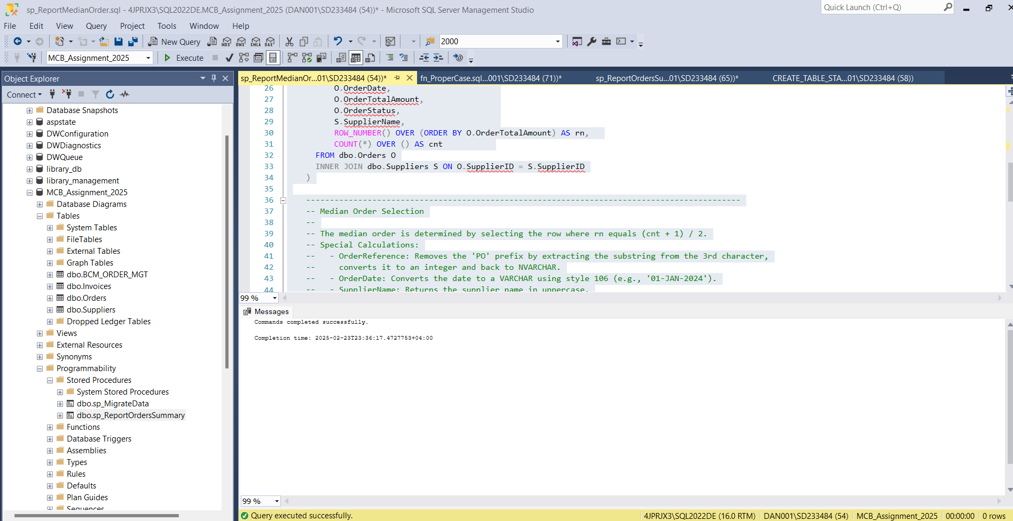

Return details for the median value of the Order Total Amount from the list

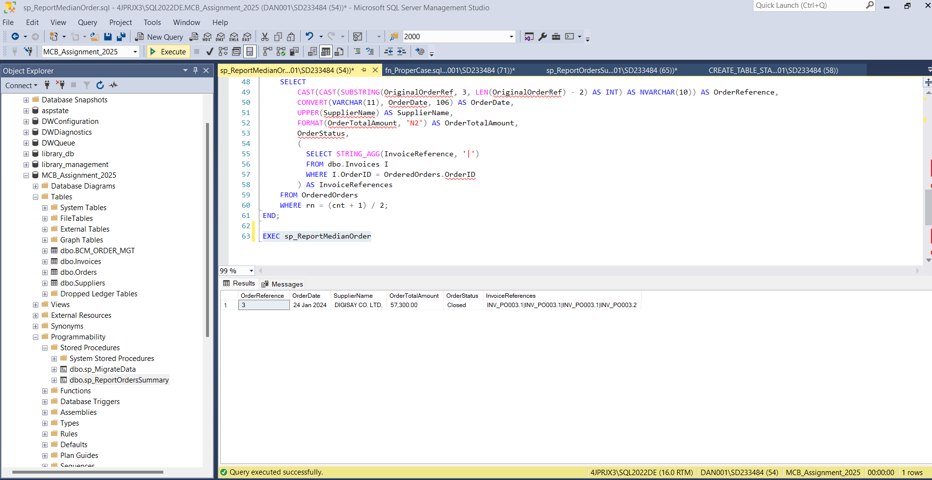

1. List all suppliers with their respective number of orders and total amount ordered from them between the period of 01 January 2024 and 31 August 2024, ordered by number of orders. Output details as per below month-wise. Implement a Stored Procedure or Function to return the required information.

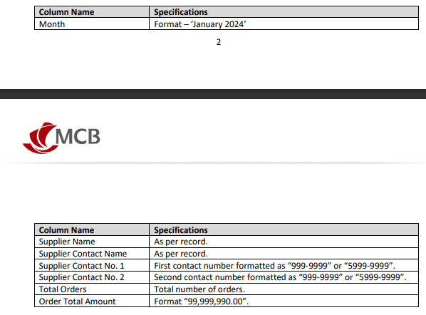

Created stored procedure to return required information as per the table above

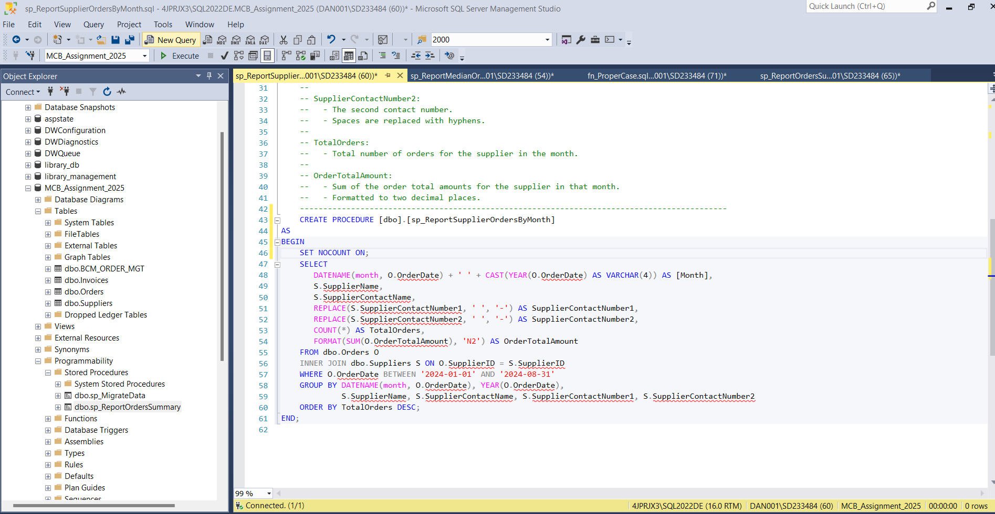

Executed Stored Procedure Successfully

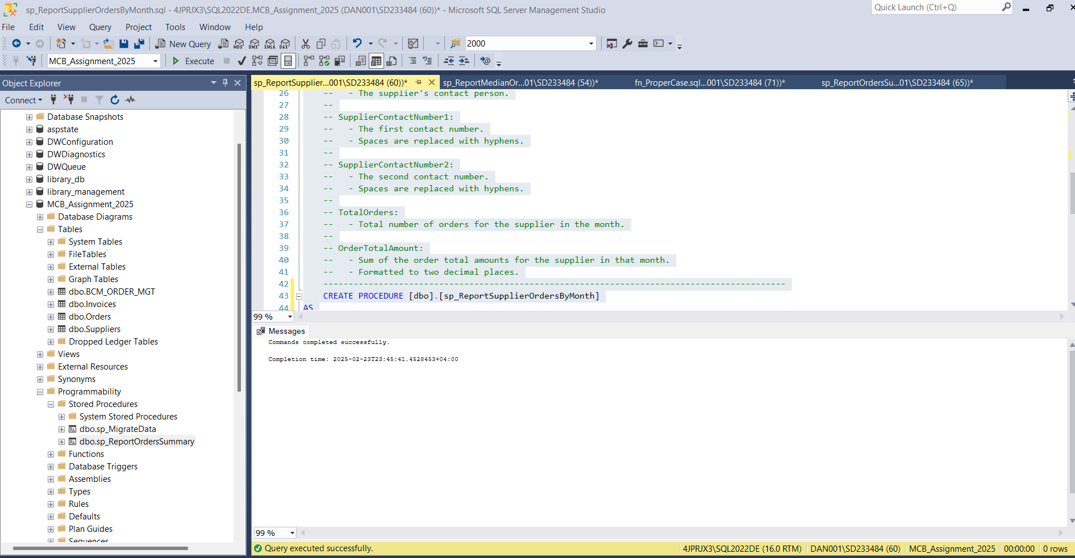

Stored procedure created successfully

List all suppliers with their respective number of orders and total amount ordered from them between the period of 01 January 2024 and 31 August 2024, ordered by number of orders